Project Valkyrie

Designing a Premium DIY 3d printer

Discord channel: https://discord.gg/C77tsY5

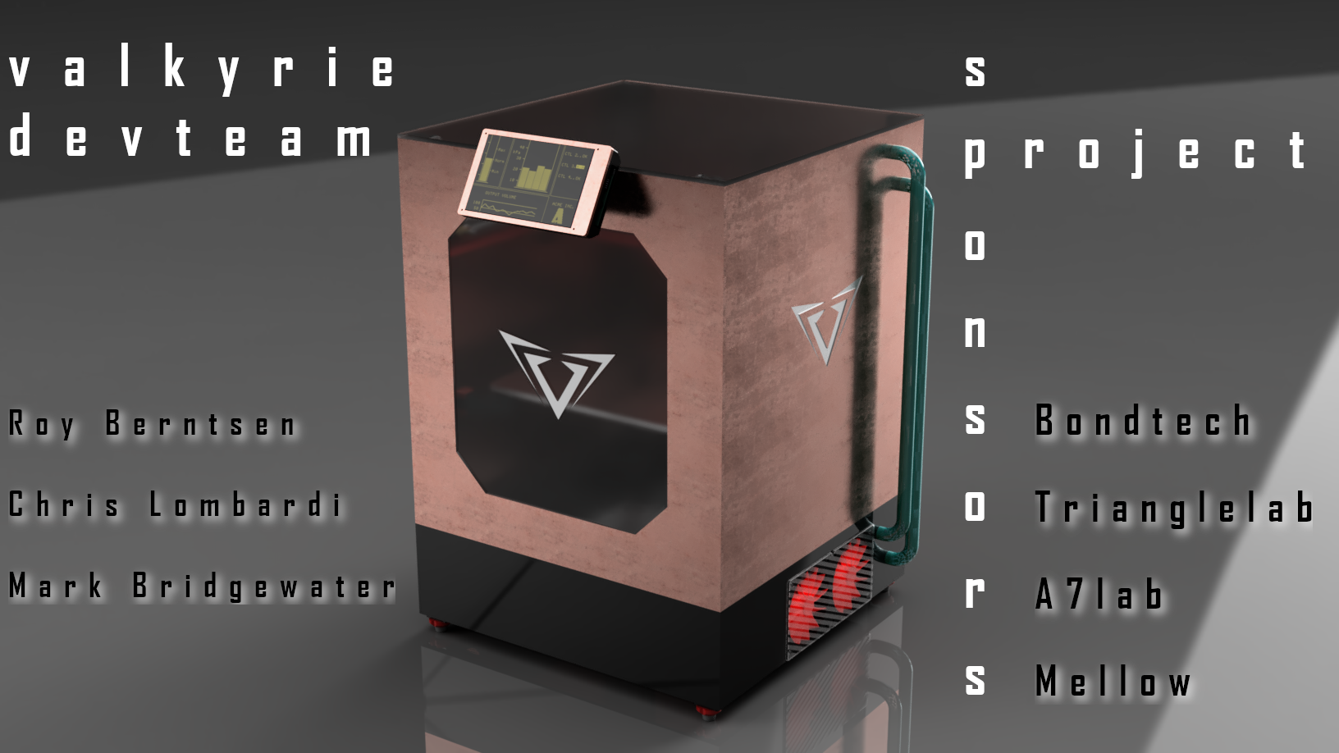

# By Roy Berntsen

M.Sc Engineering Design

Juli 2021

# The Development Team

Roy Berntsen

Mark Bridgewater NZ  
Chris Lombardi US

General Terms & Conditions

# General Requirements

## Product Choice

The aim is to develop a Premium DIY FDM 3d printer for the DIY 3d printer community.

* The machine should have an advanced Z lift with kinematic coupling
* We want to be able to print high temp materials
* The project will be open source
* Size should be scalable < 500
* Standard alu profiles. 2040 or 3030
* Belted Z or Ballscrews
* Advanced top of the line Firmware
* Premium controller
* Premium Plug And Play Cable Management

## Function Choices

The machine should have all the functions needed for a trouble-free user experience. The aim is to implement all basic functions plus any feature that is making a premium 3d printer.

* Auto tramming of the kinematic Z lift
* We want to be able to connect to the printer by internet

# Competition

* Ratrig V-Core 3
* Hevort
* Voron
* BLV MGN Cube
* Annex Engineering
* VZBot

# Design Requirements

Defining constraints and requirement guidelines to drive the design process.

|  |  |  |  |
| --- | --- | --- | --- |
| Product Requirements | Essential | Nice To Have | Not So Important |
| **Frame Requirements** |  |  |  |
| Fully Enclosed Frame | X |  |  |
| Blind Joints for Frame Assembly |  |  | X |
| Carbon profile for X axis |  | X |  |
| 3030 Aluminum Profiles |  | X |  |
| Best Possible Center of Gravity (COG) | X |  |  |
| **Build Plate Requirements** |  |  |  |
| t~8mm Fine milled Cast Aluminum build plate | X |  |  |
| **Enclosure Guidelines** |  |  |  |
| Hepa Filter |  | X |  |
| Active Heating |  | X |  |
| Separate AC & DC Components |  | X |  |
| Drybox Cabinet for Filament | X |  |  |
| Active heating for Drybox |  | X |  |
| Lighting in the Enclosure | X |  |  |
| **Drybox Guidelines** |  |  |  |
| Loadcell for filament weight and RH% |  | X |  |
| Fan for circulate the air | X |  |  |
| Heater | X |  |  |
|  |  |  |  |
|  |  |  |  |
|  |  |  |  |
| **Toolhead Requirements** |  |  |  |
| Watercooled Hotend |  | X |  |
| Tool Board for Connectors | X |  |  |
| Direct Drive |  | X |  |
| Multi Extrusion |  |  | X |
| Nozzle Cleaning Function |  | X |  |
| Loadcell for probing and crash detection |  |  | X |
| **Electronics Requirements** |  |  |  |
| > 24V for DC stuff (12v/5v/3.3v where needed) | X |  |  |
| AC Silicone Heater for Build plate heating | X |  |  |
| **Linear Movements** |  |  |  |
| MGN Rails - 12 for Y, Z and 9 for X | X |  |  |
| Maxwell Kinematic Z Lift | X |  |  |
| Belt - High End GT2 Idlers or similar Bearings | X |  |  |
| Belt - 2GT Gates Powergrip 9 Belt | X |  |  |
| Belts running backside on bearings |  | X |  |
| 0.9 High Torque Steppers for X, Y |  | X |  |
| Stepper Motors Outside | X |  |  |
| Belt Tensioning on XYZ | X |  |  |
| Auto Tramming / Auto Bed Leveling | X |  |  |
| All Metal Carriers and Parts Option |  | X |  |
|  |  |  |  |
|  |  |  |  |
|  |  |  |  |
|  |  |  |  |
|  |  |  |  |
| **Controller and Firmware Features** |  |  |  |
| Resume function |  |  | X |
| 6 Stepper drivers minimum (2209 or better) | X |  |  |
| Integrated on board stepper drivers |  |  | X |
| Touch Screen |  | X |  |
| Filament Sensor | X |  |  |
| Internet Connection | X |  |  |
| Thermo Sensors for High Temp Materials |  | X |  |
| Sensorless Homing |  |  | X |
| **Cable Management** |  |  |  |
| Plug And Play Cables And Connectors | X |  |  |

# 

# Supplier List

* Makersupplies
* Ratrig
* Motedis
* RS Components
* CRD? <https://crd-devices.co.uk/>
* Digikey
* Elfa
* Farnell
* Mauser?
* Aliexpress
  + Mellow Store
  + Fysetc Store
  + Triangle Lab Store
  + BigThreeTech Store